On The Job Training – Menus, Meals, and Kitchen Module Facilitator’s Guide

# Objective

The following is a step-by-step guide for you, the Facilitator, that is providing on-the-job training to Idaho Youth Ranch (IYR) Youth Specialists (YS). As part of IYR’s learning philosophy, you will be providing the YSs with just-in-time learning, which means helping them acquire timely knowledge and skills that are applicable to a particular problem they will encounter on-the-job.

Furthermore, you will be helping YSs to acquire these knowledge and skills using a Tell-Show-Do method. By following this Facilitator’s Guide, you will be *telling* the YSs what they need to know about a particular task (content), *showing* them how to perform that task (demonstration), and then allowing them to *do* that task (application). Once the YS has reached a satisfactory level of performance on the tasks, they will be evaluated using an evaluation form. [Note: Evaluation is not part of the training program at this time, but will be incorporated at a later time]. There is nothing that the YS will be evaluated on that they have not seen and done in training.

You as a Facilitator will:

* Ensure content is reviewed as outlined in this Facilitator’s Guide
* Ensure demonstrations are provided as outlined in this Facilitator’s Guide
* Highlight things that may be critical, difficult, or complex for inexperienced YSs as outlined in this Guide and using your own experiences
* Guide, coach, and provide feedback as the YSs move from novice to satisfactory performance levels
* Ensure YSs are allowed to apply their knowledge and skills in the applications as outlined in this Guide
* Provide diminishing levels of guidance and coaching with emphasis primarily on providing feedback (save until the end) as YSs move through the applications as outlined in this Guide and based on your own instructional experience
* Evaluate the YSs using the Post-Training Evaluation Form [Note: At this time, evaluation is informal. Formal evaluation will be incorporated into the training program at a later time].

An outline of the number of demonstrations and applications are presented in Table 1.

**TABLE 1.** Outline of On The Job Training

|  |  |  |  |
| --- | --- | --- | --- |
| **Phase** | **Demonstration by Facilitator** | **Application (Practice) for YS** | **Evaluation (Test) for YS** |
| Breakfast |  |  |  |
| Lunch |  |  |  |
| Dinner |  |  |  |
| Snack |  |  |  |

Before beginning the training day, ensure you have ready:

* Facilitator’s Guide
* IYR Self-Paced Training Participant Notes
* Recipe Cards for meals you will be preparing (if available)
* Work Flow Job Aid for Hands of Promise or Hays House – Before, During, and After (3 cards total)
* Post-Training Performance Evaluation Form

# Activation Phase – Introduction/Why Am I Here?

The first phase is where you help the YS establish a mindset of thinking and learning about menus, meals, and kitchens. This occurs through a discussion (Readiness Activity). The following is a script that you can use to complete this beginning portion of the training.

|  |
| --- |
| Ask Remember that big family meal that was part of the presentation that you watched before you came today? We mostly talked about that meal in terms of having a plan and keeping it organized. This time let’s think about that family meal in a different way. *What are some good or bad things that can happen during these family meals?* |

|  |
| --- |
| Facilitate Engage in discussion about the question presented and emphasize:   * *Pros:* Everyone is feeling a sense of community, people to talk to, bonding, storytelling, support (mission of IYR) * *Cons:* Busy and unorganized food preparation and serving, people talking over each other/getting lost in the shuffle, not everyone gets to eat what they want, messiness, not a lot of support can be given or engagement/community (anti-mission of IYR) |

|  |
| --- |
| Ask *So how can we take the best parts of a family meal and get rid of the worst parts so that everyone is in a safe and supportive environment, gets enough to eat, uses proper table manners, and the food is prepared and stored in a sanitary manner?* |

|  |
| --- |
| FacilitateEngage in discussion about the question presented and emphasize the importance of having a plan, using a recipe, step-by-step procedures, etc. [No right answer] |

|  |
| --- |
| Transition Say to the YS: These are all great ideas. One way is to create a set of steps before, during, and after a meal/snack. By doing this, we can make sure that we do all the things that we need and want to do properly and in a logical order including preparing a meal/snack, keeping youth safe, engaging them in the process, enjoying a peaceful meal/snack, and supporting during clean up afterwards.  This is where our job aids come into place. You may remember the mention of a job aid a little bit from the presentation. We are going to use these job aids as a guide, a checklist, a reminder of sorts. When you are doing these tasks, it will remind you of all the things that you need to do and be aware of on the job.  So before you actually have to do, let me show you how to properly go through this set of steps using the job aid. We are going to tackle one of the harder meals/snacks so you can see all of the different things that you might need to do – Dinner. |

# Demonstration Phase – The Dinner – Tell Me, Show Me!

The second phase is where you will be showing the YS a meal or snack. Learning is imitative, so you will want to properly show/demonstrate what a YS *should* be doing before, during, and after the meal/snack so the YS can watch and then later do.

During this phase, you will want to first introduce the YS to the objectives from both IYR (the organization) and the YS’s point-of-view. This will be introduced as part of a short discussion with the YS to activate prior knowledge from the self-paced training (PPT) and activation phase. In addition, it also engages them and focuses their attention. In order to allow for enough time for the discussion before beginning meal/snack preparation, you should begin this discussion **approximately 20 minutes prior to the beginning of the designated meal preparation time.** This discussion does not have to be extremely detailed, but instead seeks to answer the general questions:

* What is IYR’s organizational goal before the meal? During the meal? After the meal?
* What is your individual goal as a YS before the meal? During the meal? After the meal?

During this discussion, you can fill in the blanks using the information contained on the next page. Following this discussion, you will then demonstrate the tasks before, during, and after the **Dinner meal** integrating the Work Flow Job Aid in your demonstration. The Dinner meal represents the most complex of the meals/snacks that the YS will most likely encounter, but also allows for the most time and includes all the elements that the YS will have to consider as part of task completion. The complexity of these demonstrations will be controlled to focus on easy and movement towards harder tasks through the manipulation of conditions including recipe difficulty, schedule constraints, cleanup (mess level), and behavioral issues. Each demonstration will contain varied characteristics as noted on Table 2.

**TABLE 2.** Outline of Demonstrations

|  |  |  |  |  |
| --- | --- | --- | --- | --- |
| **Demonstration** | **Recipe Difficulty** | **Schedule Constraints** | **Cleanup (Mess Level)** | **Behavioral Issues** |
| **Demo #1** | Easy | Easy | Easy | Easy |
| **Demo #2** | Moderate | Moderate | Moderate | Moderate |

In the first demonstration, you want to be aware that it will be easy to overload the YS with too much information. The first demonstration should really highlight the overall work flow before, during, and after the meal along with use of the Work Flow Job Aid. You are trying to show the YS the “big picture.” In addition, time and workload permitting, you will also want to...

* Highlight things that might be critical, complex, or difficult so the YS can know what to focus their attention on
* Focus their attention on tips of the trade from your own experiences or subtleties that they may otherwise miss
* Use your words and motions to focus their attention like a flashlight to things that are important to their performance
* In the second demonstration, you will be able to increase the depth of this focus and additional information that is presented

You must also be positive and supportive of YSs answering any questions that they may have. In both demonstrations, you should be verbalizing what you are thinking and doing so that the YS may understand what they need to do and how they need to think in order to achieve satisfactory performance.

|  |
| --- |
| Ask and Facilitate Ask and facilitate a discussion - *What is IYR and you, as the YS, trying to achieve* ***BEFORE*** *the meal?*  Objectives Before the Meal:   * Menu approved meal/snack prepared using proper ingredients and directions * Meal/snack prepared in compliance with safety/sanitary/food handling guidelines * Prepared on-time * Youth are in line-of-sight * Youth are encouraged to take part in preparation * Signals youth that it is time to eat * No personal injury or property damage   Organizational Goals in a nutshell – Prepare according to menu on-time, minimize wastefulness or injury/damage, supervise and engage youth for positive experience, minimize disruption to schedule  Individual Goals in a nutshell – Prepare proper meal/snack in accordance with guidelines to prevent injury/damage, stay organized to prevent disruption/high workload, keep everyone in sight and engaged, begin eating on time |

|  |
| --- |
| Ask and Facilitate Ask and facilitate a discussion - *What is IYR and you, as the YS, trying to achieve* ***DURING*** *the meal?*  Objectives During the Meal:   * Youth are supervised (line of sight) while self-serving food and eating * Safety and sanitation guidelines are followed * Engaged conversations that support youth during meal/snack time * Modeling of proper table etiquette, table manners, and portion control for youth and correction of poor etiquette, manners, and portion control * Meal/snack time is monitored and adjusted to maintain schedule integrity * Signals youth that meal/snack time is over * No personal injury or property damage   Organizational Goals in a nutshell – Meal is served including a moment of silence, management of youth behavior including modeling proper table manners/etiquette and portion control, and engagement in relationship building through communication and conversation during the meal to support the family atmosphere/treatment.  Individual Goals in a nutshell – Communicate/converse with youths during the meal demonstrating proper manners and etiquette as well as developing relationships/community with the youth, support youths in identifying proper portions, and signal the end of the meal to begin cleanup. |

|  |
| --- |
| Ask and Facilitate Ask and facilitate a discussion - *What is IYR and you, as the YS, trying to achieve* ***AFTER*** *the meal?*  Objectives:   * Supervises (youth in line of sight) during assigned/voluntary post meal/snack time cleanup duties * Detection and correction of improper behavior during cleanup * Ensures tasks are completed including dishes prepared for dishwasher, leftovers put away, table cleaned, sweeping of kitchen/dining room, mop of kitchen/dining room (dinner time) * Able to conduct Kitchen Audit * Follow sanitation and safety guidelines when storing food and cleaning supplies * Communicate when cleanup is complete * Monitors and amends after the meal process to achieve schedule integrity * No personal injury or property damage   Organizational Goals in a nutshell – The eating area and kitchen are cleaned up in compliance with safety and sanitary guidelines including storage of food. This minimizes workload/distractions for the YS, incorrect storage or wasteful use of food supplies, and maintains a safe and clean environment while maintaining line of sight with youths.  Individual Goals in a nutshell – When the YS signals, the cleanup by designated youths or volunteers begins leaving the kitchen and eating area clean and food stored in compliance with safety and sanitary/food handling guidelines. This occurs within a minimal amount of time so youths can proceed to the next activity and stay on schedule. |

|  |
| --- |
| Transition Say to the YS: So these are some of the things that we are trying to accomplish so that IYR can meet their goals and mission and you, as a YS, can improve your skills and gain confidence and proficiency in your job.  But, this is a lot of things to remember! One way that we can minimize the number of things that you need to remember is through the Work Flow Job Aid. This is a memory aid with all of the major tasks and important things to remember that you will need before, during, and after the meal/snack. As I show you the things that we will be doing before, during, and after the dinner, I will be referencing this Work Flow Job Aid so we can stay organized. Once you start doing YS tasks on your own, please use the Job Aid as much or as little as you need. With practice, you will probably need to rely on it less and less. However, it is still always there if you need it for a quick review or as a way to stay organized. |

|  |
| --- |
| Demonstration – Before the MealYou should emphasize that the YS has the proper job aid. Each facility has its own set of job aids that are specific to the subtle differences between Hays and Hands of Promise. The facility name is located in the Job Aid header as shown in Figure 1.  Ensuring that the Work Flow Job Aid is in hand for the facility (Hands of Promise or Hays House), work from the top left to bottom left and then top right to bottom right as shown by the arrows in Figure 2.  Though you will want to go through the job aid line-by-line, it is important to highlight the things in green arrows next to the job aid sections as noted in this Guide. This helps to specifically show the YS areas that align with organizational and individual goals and help to keep focus on the “big picture.”  For the first demonstration, you will want to:   * Recipe: Choose a recipe that is **easy** in difficulty (green circle on Recipe Card if available) * Schedule: Ensure that there are no activities scheduled right after the Dinner meal so that the schedule is **easy** * Cleanup:Employ other YSs/IYR staff to increase/decrease the level of messiness that you will have to clean up after the meal to an **easy** level * Behavioral Issues: Talk with youths ahead of time and ensure that they are aware to be on their best behavior and identify/make alternative plans for any youths that may create behavioral issues so that the conflict level will be **easy\***   For the second demonstration, you will want to:   * Recipe: Choose a recipe that is **moderate** (yellow circle on Recipe card) * Schedule: Ensure that there is an activity that is scheduled shortly after the meal/snack time that is flexible in attendance creating a **moderate** level of schedule constraints * Cleanup:Employ other YSs/IYR staff to increase/decrease the level of messiness that you will have to clean up after the meal to a **moderate** level * Behavioral Issues: Talk with youths ahead of time and ensure that they are aware to be on their best behavior and identify/make alternative plans for any youths that may create behavioral issues. However, work with IYR staff/YSs and youths to stage a behavior issue that will create a **moderate** conflict level*   When adjusting behavioral issues/conflict levels, safety must always come first. All YSs/IYR staff present and other youths must be made aware when a conflict/behavioral issue will be staged for the purpose of training. A staged behavioral issue will not include any sharps, chemicals, or other potentially harmful items/substances. The behavioral issue that is to be staged must be approved by the Assistant Program Director/Program Director that will be on staff at the time of training |

**FIGURE 1.** Work Flow Job Aid headers.



**FIGURE 2**. Work Flow Job Aid direction of actions.

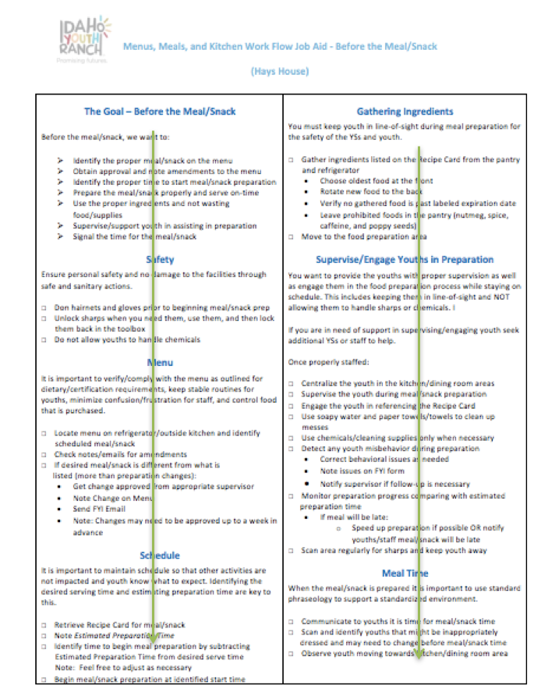

# Before the Meal

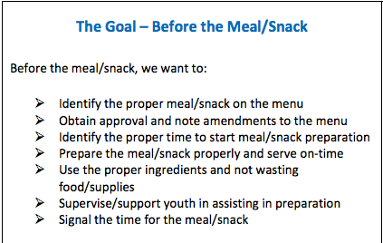

This is an overview of the “big picture” and reminder of what you, as the YS, are trying to accomplish

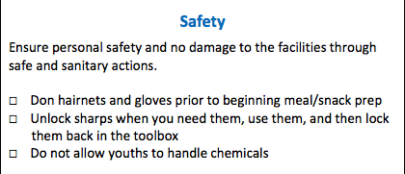

Safety is the most important goal for IYR. Following these steps will ensure safety for the YS, youth, and IYR staff.

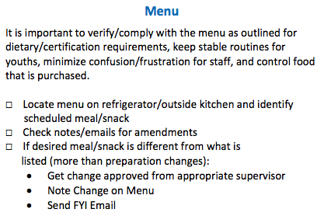

Complying with the published menu is vital to ensuring the meal/snack is nutritious and IYR maintains proper supplies.

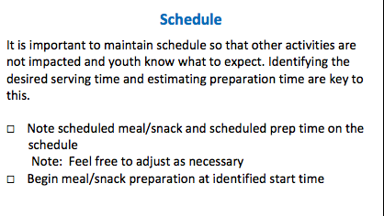

It is important for YSs to manage time properly so that youth have enough time to engage in meal time, but are not late to their next scheduled activity.

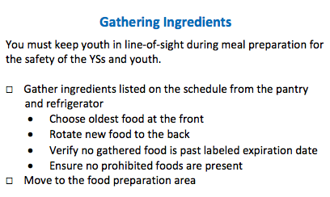

Success in the subtle nuances of supervising and engaging youth comes from practice and reaching out to IYR staff/YSs for help.

Preventing waste and avoiding illness due to poor food handling starts even before meal preparation. Rotating food to ensure the oldest is being used first starts when YSs gather ingredients.

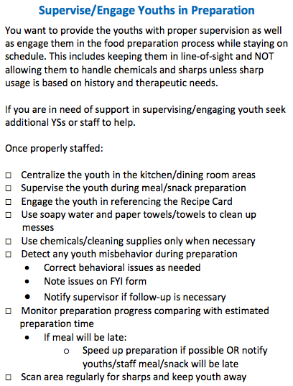

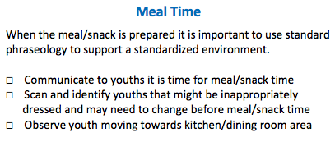

A standard signal indicates Before the Meal preparations are complete and the YS will need to reference the During the Meal Work Flow Job Aid

|  |
| --- |
| Ask and Facilitate Ask and facilitate a discussion - *So what was easy about the Before the Meal? What was hard?*  There are no right/wrong answers to these questions. Instead this will give you as the Facilitator an idea of what areas may best easiest or hardest for the learner and where you may need to spend extra time during the Application phase. It also gives an opportunity to have an open environment where you can answer questions for the YS. |

|  |
| --- |
| Demonstration – During the MealYou should emphasize that the YS has the proper job aid.  Though you will want to go through the job aid line-by-line, it is important to highlight the things in green arrows next to the job aid sections as noted in this Guide. This helps to specifically show the YS areas that align with organizational and individual goals and help to keep focus on the “big picture.”  For during the meal, it is best to read through the job aid before commencing the meal/snack time since the pace is much quicker and the ability to reference the Work Flow Job Aid may be less. Thus, the YS should scan the job aid prior to and during as needed.  Remember, for the first demonstration, you will want to:   * Schedule: Ensure that there are no activities scheduled right after the Dinner meal so that the schedule is **easy** * Behavioral Issues: Talk with youths ahead of time and ensure that they are aware to be on their best behavior and identify/make alternative plans for any youths that may create behavioral issues so that the conflict level will be **easy\***   For the second demonstration, you will want to:   * Schedule: Ensure that there is an activity that is scheduled shortly after the meal/snack time that is flexible in attendance creating a **moderate** level of schedule constraints * Behavioral Issues: Talk with youths ahead of time and ensure that they are aware to be on their best behavior and identify/make alternative plans for any youths that may create behavioral issues. However, work with IYR staff/YSs and youths to stage a behavior issue that will create a **moderate** conflict level*   * When adjusting behavioral issues/conflict levels, safety must always come first. All YSs/IYR staff present and other youths must be made aware when a conflict/behavioral issue will be staged for the purpose of training. A staged behavioral issue will not include any sharps, chemicals, or other potentially harmful items/substances. The behavioral issue that is to be staged must be approved by the Assistant Program Director/Program Director that will be on staff at the time of training |

# During the Meal

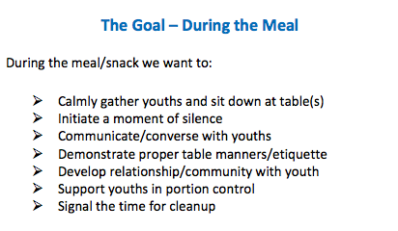

This is an overview of the “big picture” and reminder of what you, as the YS, are trying to accomplish

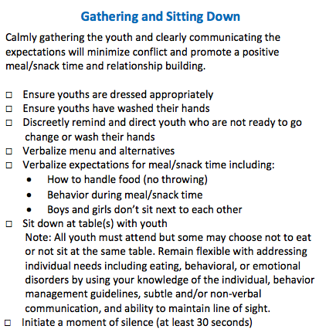

The YSs should clearly set expectations for meal/snack time

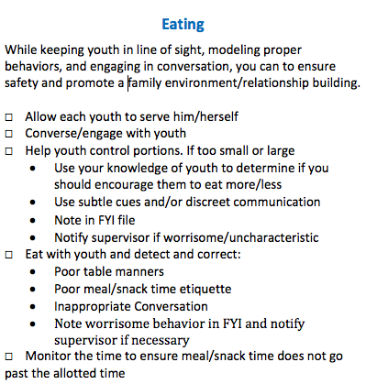

One of the most important parts of the meal/snack time is to engage youth in conversation and support community

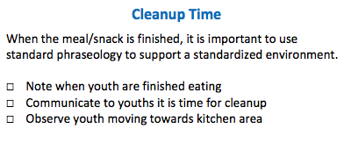

A clear signal that meal/snack time is over is an important cue to help youth know that it is time to cleanup. Too early and you miss out on important conversation/community, too late and youth may become distracted or bored increasing the potential for behavioral issues

|  |
| --- |
| Ask and Facilitate Ask and facilitate a discussion - *So what was easy about the During the Meal? What was hard?*  There are no right/wrong answers to these questions. Instead this will give you as the facilitator an idea of what areas may best easiest or hardest for the learner and where you may need to spend extra time during the Application phase. It also gives an opportunity to have an open environment where you can answer questions for the YS. |

|  |
| --- |
| Demonstration – After the MealYou should emphasize that the YS has the proper job aid.  **Demonstration #1** - Have other YSs or IYR staff cleanup if excessive messiness or artificially create additional messes so there is an **easy** level of cleanup.  **Demonstration #2** - Have other YSs or IYR staff cleanup if excessive messiness or artificially create additional messes so there is a **moderate** level of cleanup.  Though you will want to go through the job aid line-by-line, it is important to highlight the things in green arrows next to the job aid sections as noted in this Guide. This helps to specifically show the YS areas that align with organizational and individual goals and help to keep focus on the “big picture.” |

# After the Meal

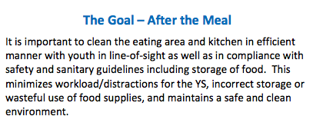

Taking a moment to review what the YS is trying to achieve in this phase of the process is important in focusing attention

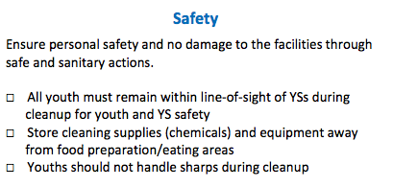

Safety remains an important concern and focus with the introduction of cleaning supplies and equipment

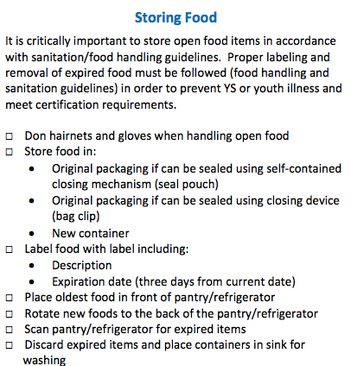

There are several important times when the YS must store and rotate food – during the gathering of ingredients and after the meal/snack. This is important to maintain safety, sanitary guidelines, and prevent waste.

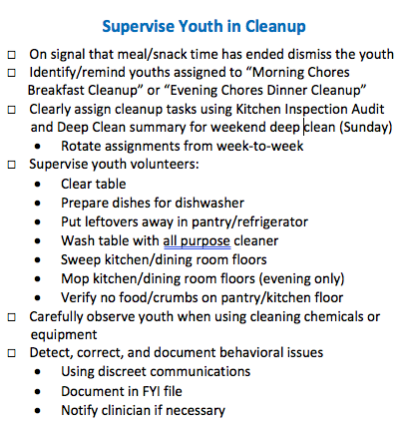

It is important to support and monitor youth that have been assigned or have volunteered for a cleanup task. This not only ensures workload distribution, but is also important in building community and fostering proper behavior/discipline

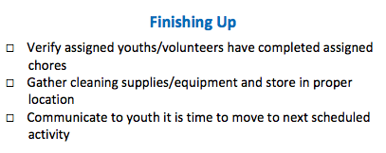

Moving on to the next scheduled activity is the signal that the menus, meals, and kitchen module has ended

|  |
| --- |
| Ask and Facilitate Ask and facilitate a discussion - *So what was easy about the After the Meal? What was hard?*  There are no right/wrong answers to these questions. Instead this will give you as the facilitator an idea of what areas may best easiest or hardest for the learner and where you may need to spend extra time during the Application phase. It also gives an opportunity to have an open environment where you can answer questions for the YS. |

|  |
| --- |
| Transition Say to the YS: So this was a good first view at all of the things that you will be coordinating before, during, and after a snack or meal. Your next training session, you will be doing the exact same thing except this time the circumstances in terms of schedule, recipe difficulty, and cleanup will be a little bit different. But it doesn’t matter, using your Work Flow Job Aid you will be able to conquer any type of situations that come your way. You are also not alone. You will always have other IYR staff and YSs around to lean on and help. Reach out to them when you need support or have questions. |

# Application Phase – Let Me Do!

The third phase is where you will be allowing YSs to practice for both meals and snacks. Now that YSs have been shown the hardest of the meals/snacks (dinner), they will be able to take this knowledge and practice over the course of several meals/snacks. The important part of this phase is not to develop skills regarding basic food preparation, time/workload management, or following policies which are skills the YS should already have coming into the training. Instead, these applications provide realistic on-the-job training that includes guidelines through the use of job aids, feedback, coaching, and best practices by exemplary performers. This will improve the YS’s ability to create a safe, nurturing, and consistent environment that supports youth’s treatment and minimizes behavioral issues.

During this phase, you will want to start by briefly reviewing the things that were hard about the demonstrations from the YS’s point-of-view. You can take your notes from the discussions that were part of the Demonstration phase and engage the YS in a brief discussion summarizing these. As you proceed through the applications, make sure to remember these areas that the YS has concerns about and highlight them. This will not only engage the YS because you are addressing something that is of interest or concern to them, but will also help to build confidence. You should also take this time to answer any questions that the YS has. You should begin this discussion **approximately 20 minutes prior to the beginning of the designated meal preparation time.**

When possible, minimize distractions in the early applications so that the YS can focus on learning the work flow, making decisions, and developing a firm mental model of the nuanced psychomotor actions that are part of the menus, meals, and kitchens tasks. As applications continue and the YS becomes more confident, distractions as they occur should be welcomed into the training environment.

Following this discussion, you will then manipulate variables that vary the conditions of the task allowing the YS to build skill and confidence. These varying conditions are seen in Table 3 below.

**TABLE 3.** Outline of Applications

|  |  |  |  |  |  |
| --- | --- | --- | --- | --- | --- |
| **Demonstration** | **Recipe Difficulty** | **Schedule Constraints** | **Cleanup (Mess Level)** | **Behavioral Issues** | **Guidance/ Coaching/ Feedback** |
| **Application #1 – Breakfast** | Easy | Easy | Easy | Easy | During & After Guidance, Coaching, and Feedback |
| **Application #2 – Lunch** | Moderate | Moderate | Moderate | Easy | During & After Guidance, Coaching, and Feedback |
| **Application #3 – Dinner** | Moderate | Moderate | Difficult | Moderate | During & After Coaching and Feedback |
| **Application #4 – Snack** | Moderate | Difficult | Moderate | Moderate | During & After Coaching and Feedback |
| **Application #5 – Breakfast** | Difficult | Difficult | Difficult | Difficult | During & After Feedback |
| **Application # 6 – Dinner** | Difficult | Difficult | Difficult | Difficult | During & After Feedback |
| **Application # 7 – Dinner** | Difficult | Difficult | Difficult | Difficult | After Feedback |

The condition levels are described in more detail below:

Recipe

* **Easy** (Green circle on Recipe Card if available) – generally a microwavable or combining separate pre-made components
* **Moderate** (Yellow circle on Recipe Card if available) – involves some preparation of individual components and/or complex combinations of separate ingredients to create a whole
* **Difficult** (Red circle on Recipe Card if available) – involves preparation of individual components and complex combinations of those separate ingredients to create a whole

Schedule Constraints

* **Easy** - No scheduled activities within 1 hour after meal/snack time
* **Moderate** – Scheduled activities within 1 hour after meal/snack time
* **Difficult** – Scheduled activities within 30 minutes after meal/snack time

Cleanup (Mess Level)

* **Easy** – less than four leftovers to put away, requires light sweeping/mopping (dinner), and cleaning of surfaces with all-purpose cleaner
* **Moderate** – four or more leftovers to put away, requires light sweeping/mopping (dinner), and requires some additional time to clean surfaces with all-purpose cleaner
* **Difficult** – four or more leftovers to put away, requires additional time for sweeping/mopping (dinner), and requires additional time to clean surfaces with all-purpose cleaner. Also requires referencing the weekly kitchen deep clean inspection procedures

Behavioral Issues

* **Easy** – no behavioral issues other than excessive talking by youth
* **Moderate** – two or less behavioral issues that require YS intervention to manage
* **Difficult** – more than two behavioral issues that require YS intervention to manage

By varying the amount of guidance, coaching, and feedback during the applications you can help the YS to develop confidence and allow them to make decisions as well as see the results of those decisions. The opportunity to “fix” bad decisions/situations will also improve the YS’s learning and confidence. You as the Facilitator must monitor these unintended conditions to ensure that the YS does not become cognitively overloaded/overwhelmed, frustrated, or defeated. At any time if you feel that the YS’s actions or lack of actions may create or contribute to an unsafe or unsanitary condition, please intervene. This is a training environment and with dynamic conditions, it can be assumed that there may be situations arise that are beyond the YS’s skill level and require your intervention.

These terms are loosely defined as:

* **Guidance** – Directing and supporting the YS in performance of the task
* **Coaching** – Supporting the YS with tips, techniques, and comments to improve performance in the here and now (*during* task performance)
* **Feedback** – Supporting the YS with tips, techniques, and comments *after* task performance to improve that performance

In all applications, you must remain positive and supportive of YSs by answering any questions that they may have. The final two applications will mimic evaluation conditions and allow the YS to be free in performing the task with you the Facilitator acting as a “safety net.”

|  |
| --- |
| Ask and Facilitate Ask and facilitate a discussion – *What were the things that you found hard about this practice?*  There are no right/wrong answers to these questions. Instead, this will give you as the facilitator an idea of what areas may be hardest for the learner and where you may need to spend extra time during the various applications. It also gives an opportunity to have an open environment where you can answer questions for the YS. |

|  |
| --- |
| Say Say to the YS: Now it is your turn as the YS to take what you have learned during the demonstrations along with the job aids that you have available – the Recipe Cards (if available) and the Work Flow Job Aids for before, during and after the meal and practice. We are going to start out with a breakfast and use the job aid as a structure to lead us through this process. As we go along, go ahead and take the lead. I as the Facilitator will support you with guidance of what you should be doing and what will be coming next, coaching to give you tips and techniques to improve your performance, and feedback after we finish to help you perform better at the next meal/snack.  Any time you have a question, please feel free to ask. You are not being evaluated at this time. Instead, we are trying to build your skill set and your confidence. Before each meal/snack I will go over the conditions that you will encounter so that there are no surprises. In the last two applications, we will pretend as though you are going solo and I will only provide feedback after your performance. Of course, if I see anything that is unsafe or unsanitary or you are getting overwhelmed, I will intervene as necessary. This is a training environment and so I as the Facilitator are your safety net.  So let’s get started with Breakfast.... |

|  |
| --- |
| Facilitate For each application, you will reference Table 3 above and make the appropriate arrangements ahead of time so that IYR staff/YSs can help you simulate the desired conditions. In the case of clean up (mess level) or behavior, it may be necessary to “stage the scene” in order to meet the needs of the application.  In the case of staged behavioral issues, all IYR staff/YSs on staff at the time of the training must be made aware ahead of time of this desire to stage a behavioral issue to maintain the highest level of safety.  If at any time during training you as the Facilitator must step in and take control of the application to maintain safety, then you must do so.  Prior to each application  Use Table 3 to brief the YS on the conditions that will be present. For applications 6 and 7, you will minimize the level of guidance and coaching that you provide and instead leave comments until the end as part of a De-Brief feedback/questions discussion. In these two applications, the YS is doing things solo with intervention only when necessary to maintain safety (injury/property damage) or sanitary conditions.  After each application  Take 5 minutes or more if necessary, to provide feedback to the YS regarding their performance and answer any questions or address any concerns that he/she has. Use the Post-Training Evaluation Form as a checklist to guide discussion and ensure that the YS has met all expected performance goals.  ** REPEAT FOR EACH APPLICATION ** |

|  |
| --- |
| Transition After the final application, say to the YS:  Congratulations! You were able to maintain a safe, engaging, sanitary and well-balanced environment so that youth could engage in a nutritious meal/snack. Let’s finish up here and go to the dining room table to finish up our training session. |

# Integration Phase – Let Me Show Others!

The final phase is the integration phase where the YS will take what they have learned and transfer it into the day-to-day operations as a YS at IYR. Key to success in this phase is making learning personal and making it public. Each YS that goes through this training will have a different learning experience and take away something different. Standardization is key, but it is important to balance this with learning environments that increase challenges necessary to improve performance by building skills and confidence. Training must be flexible enough to ensure that YS’s have the skill set to address any challenge that might occur before, during, and after meals/snacks as opposed to just standard situations.

Training Day Closing Discussion

Following the last application (Application #7) and any evaluation events (not currently a part of this training program), the Facilitator will engage in a final training day discussion with the YS and reflect on:

* Where the YS started in the beginning and where they are now to highlight skill/personal growth
* Areas that the YS feels good about to improve confidence
* Areas that the YS wishes to improve through the creation of two personal goals

This discussion will conclude the formal training and the module will be marked complete.

|  |
| --- |
| Ask and Facilitate Ask and facilitate a discussion helping the YS to reflect on their training experience. This will include:   * *Where were you when you started – attitude/skill level? Where are you now?* * *What do you feel good about coming out of this training module?* * *What areas do you still want to improve on? What are two personal goals that you can set and work towards in the coming days?*   There are no right/wrong answers to these questions. Instead, this will help to address any areas of concern and correct any mis-perceptions regarding perceived and actual performance levels (ego vs. doubt). It will also help the learner to make the learning process personalized by engaging in the setting and planning of personal performance goals.  This discussion also gives an opportunity to have an open environment where you can answer questions for the YS. |

|  |
| --- |
| Transition Say to the YS: Thank you for doing your best during our training program and I think that an important takeaway is that you can plan for meals and snack-times, but still have to have a certain amount of flexibility to make sure youth are engaged and supported. Using the Work Flow Job Aid is an aid to help you stay focused and organized helping you to conquer any type of situation that will come your way. But, you are not alone! You will always have other IYR staff and YSs around to lean on and help. Reach out to them when you need support or have questions.  In about 7 to 10 days I will check in with you again and provide any tips or feedback that I can to help you continue to improve your performance. This will also be a great opportunity to meet back up after you have had some time to work in the real-world environment here at IYR for a while. I am looking forward to seeing how you are doing. In the meantime, if you have any questions or concerns, please reach out to me. Here is my contact information [provide email and phone number]. |

Post-Training Follow-up

However, the training day discussion is not the end. The Facilitator will observe the YS during a meal/snack between 7 – 10 days after training has been marked complete. The Facilitator will use the Meals, Menus, and Kitchen Post Training Evaluation Form as a way to informally evaluate the YS and make notes on the YS’s performance. Following the completion of the meal/snack and away from the youth, the YS and Facilitator will have a short discussion where the Facilitator will:

* Provide feedback on YS performance
* Answer questions/address concerns
* Identify areas that may need additional training/guidance/coaching
* Support the YS in reflecting upon their performance and how they are working to meet the personal goals identified at the end of training (see above)

|  |
| --- |
| Ask and Facilitate Ask and facilitate a discussion helping the YS to reflect on their training experience. This will include:   * Feedback on observed performance includes areas that might need additional training, guidance, coaching * Answer any questions/concerns * Have the YS reflect on their personal goals and how they have accomplished them or continue to try to accomplish them. Do they need to be amended?   There are no right/wrong answers to these questions. Instead, this will help to address any areas of concern and correct any mis-perceptions regarding perceived and actual performance levels (ego vs. doubt). It will also help the learner to make the learning process personalized by engaging in the pursuit and/or amendment of personal performance goals.  This discussion also gives an opportunity to have an open environment where you can answer questions for the YS. |

# Conclusion

Thanks for being an integral part of the IYR training program for new hire YSs. Your dedication to sharing your exemplary performance through guidance, coaching, and feedback is invaluable in giving new YSs the tools they need to succeed.

It is impossible to train for every situation that will arise. The learners need to do as opposed to reading. Since each situation is different, it would be impossible to provide enough scenarios that might be possible due to the variable nature of youth’s behavior, scheduling, number of meals available, youth turnover, and staff scheduling.

However, through this training program, YSs will gain the foundational knowledge and skills as well as hands on practice and confidence. Along with the Work Flow Job Aids, Recipe Cards (if available), YSs will be equipped to manage their workload using a structured approach. This will support YSs in handling any challenge that might come their way. However, critical to the IYRs mission is a team approach and so the YS is never alone in task performance. It is encouraged that they also employ the team approach and reach out when they need help or support. Thank you for being part of that support team from Day 1!